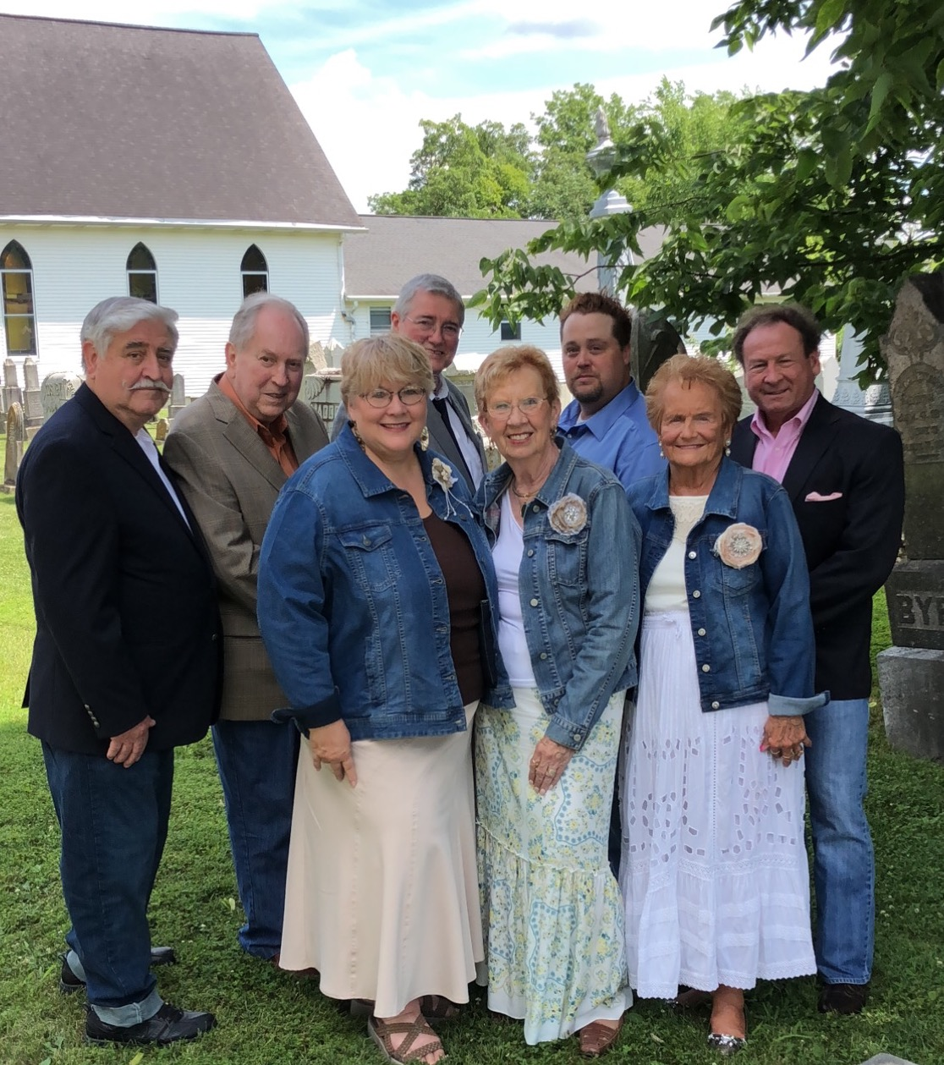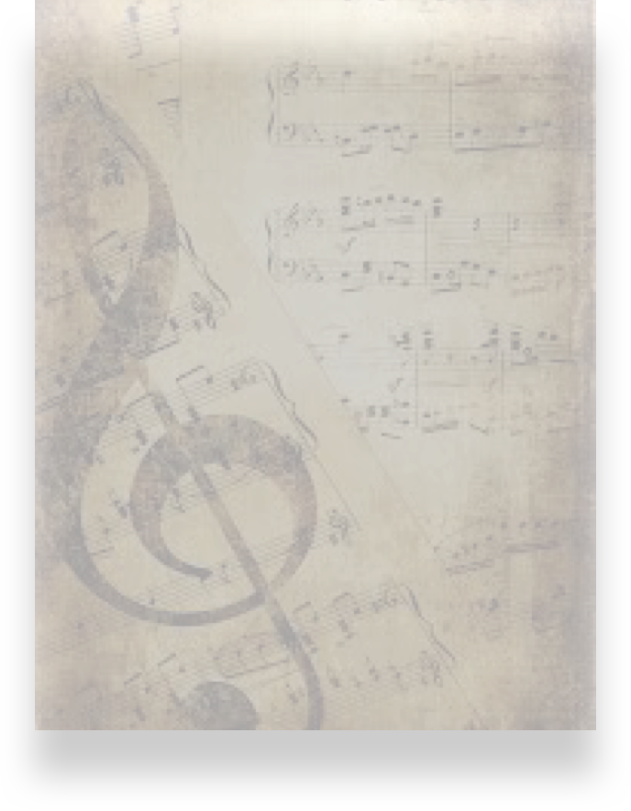

(Insert Organization Name Here)

Presents

The Ball Family Gospel Quartet

On

(insert date)

At

(Insert time)

“… come before His presence with singing” Psalm 100:2

The Ball Family Quartet

www.ballfamilyqt.com **859-431-0866** The Ball Family Quartet