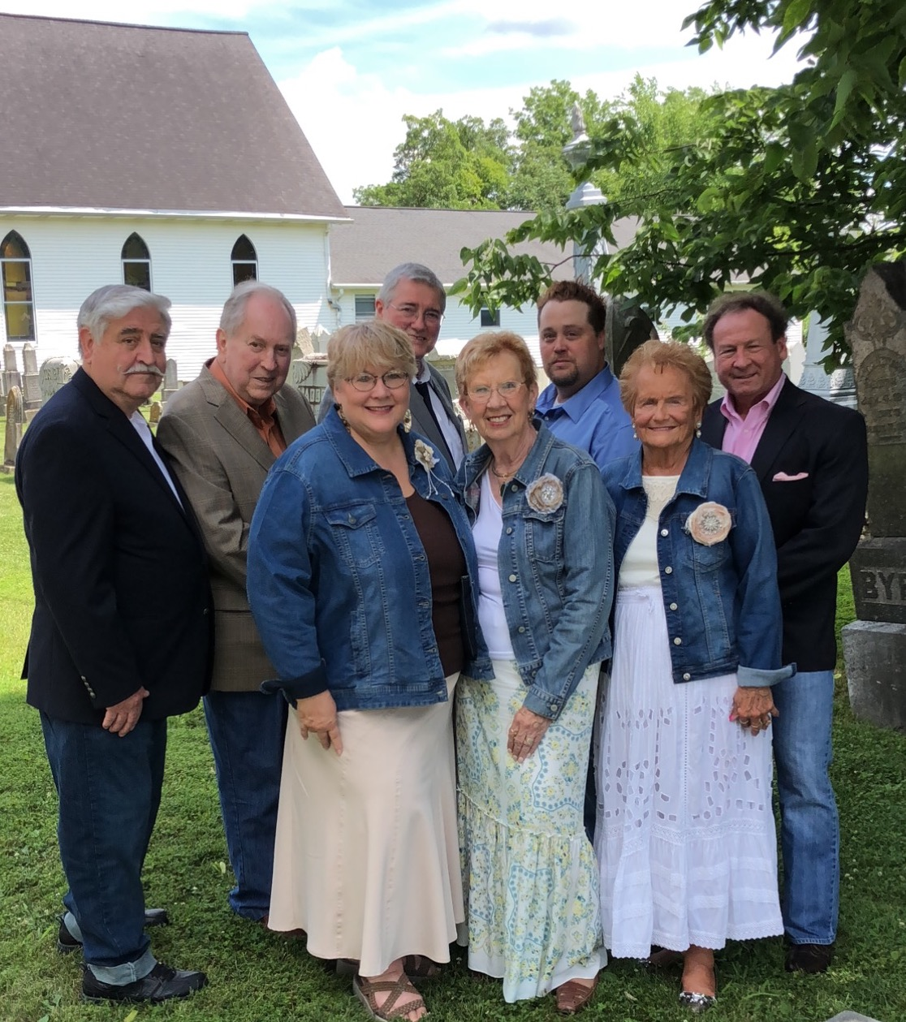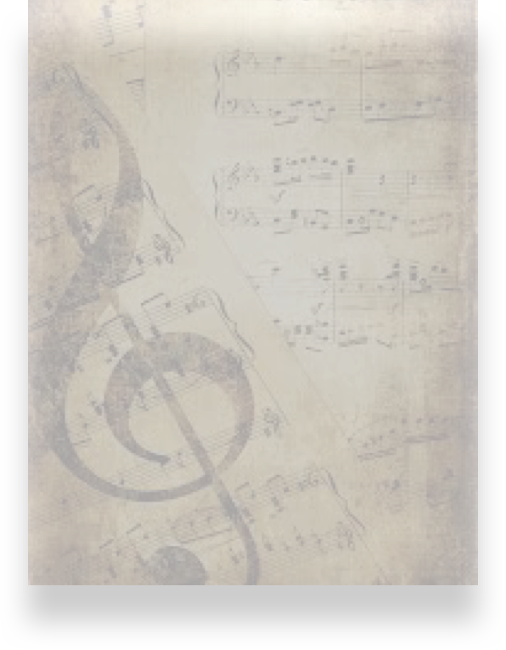

Presents

The Ball Family Gospel Quartet

On

At

“… come before His presence with singing” Psalm 100:2

The Ball Family Quartet

www.ballfamilyqt.com **859-431-0866** The Ball Family Quartet